Parenthesis Key Points
Parenthesis - a word or phrase inserted as an addition into a sentence which is grammatically complete without it.

You can use the following forms of punctuation to add parenthesis correctly: brackets (), dashes – and commas.

Below is an example where the parenthesis is used to give the reader more information about the subject.

For example: The sales assistant, wearing a top hat, wrapped my Christmas present.

The sales assistant – wearing a top hat – wrapped my Christmas present.

The sales assistant (wearing a top hat) wrapped my Christmas present.

Parenthesis adding more information about the subject can also be placed at the end of the sentence.

For example: Steve’s loved his car, a brand-new Sport Suzuki Swift.

Steve loved his new car - a brand-new Sport Suzuki Swift.

Steve loved his new car (a brand-new Sport Suzuki Swift).

You can also use parenthesis to describe the object in more detail.

Steve loved his brand-new Sport Suzuki Swift, his first car.

Steve loved his brand-new Sport Suzuki Swift – his first car.

Steve loved his brand-new Sport Suzuki Swift (his first car).

You may find it useful to see a selection of question types relating to parenthesis, that your child might be expected to answer in the KS2 SATs tests.

1. Tick the sentence that is punctuated correctly.

Tick one
The sky which was, very beautiful, made me feel peaceful.

The sky, which was very beautiful, made me feel peaceful.

The sun which was very beautiful, made me feel, peaceful.

The sun which, was very beautiful, made me feel peaceful.
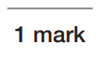

2. Insert a pair of brackets into the sentence below.

We all watched whilst Lucy and Bob my brother’s pet turtles raced each other in the garden.

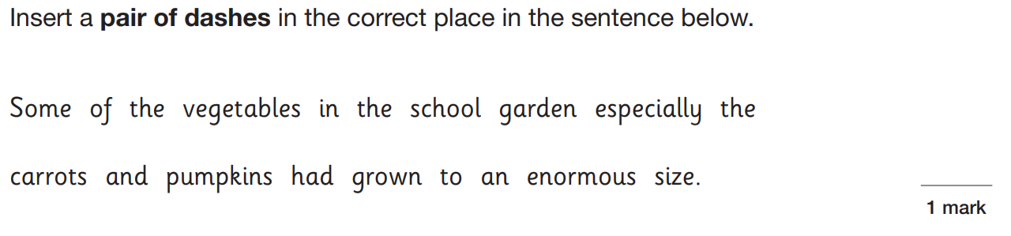
3.

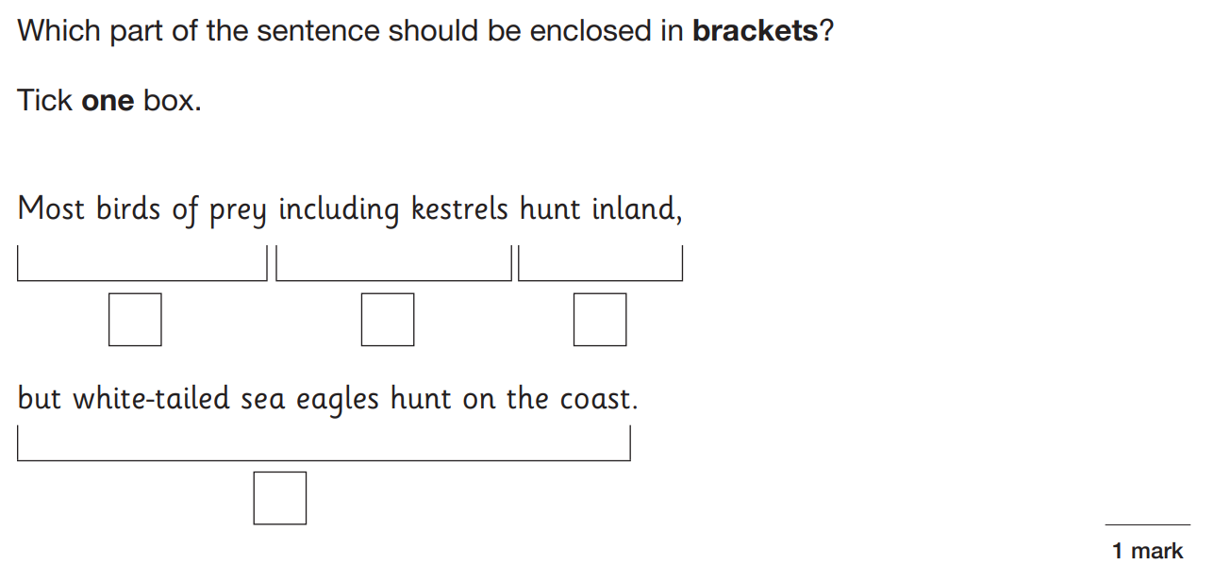
4.

KS2 Parents’ Workshop, Monday 09/01/23

